.

**Department of Computer Science and Engineering** | **Rajalakshmi Engineering College**

167



10 - Searching & Sorting

**Ex. No. : 10.1 Date: 01.06.24**



**Register No.: 230701370 Name B.VARSHA**

# Bubble Sort

Bubble Sort is the simplest sorting algorithm that works by repeatedly swapping the adjacent elements if they are in wrong order. You read an list of numbers. You need to arrange the elements in ascending order and print the result. The sorting should be done using bubble sort.

Input Format: The first line reads the number of elements in the array. The second line reads the array elements one by one.

Output Format: The output should be a sorted list.

## For example:



|  |  |
| --- | --- |
| Input | Result |
| 6  3 4 8 7 1 2 | 1 2 3 4 7 8 |
| 5  4 5 2 3 1 | 1 2 3 4 5 |

**Program:**

n=int(input())

k=[int(x) for x in input().split()]

.

**Department of Computer Science and Engineering** | **Rajalakshmi Engineering College**

168

k.sort() for i in k:

.

**Department of Computer Science and Engineering** | **Rajalakshmi Engineering College**

169



print(i,end=' ')

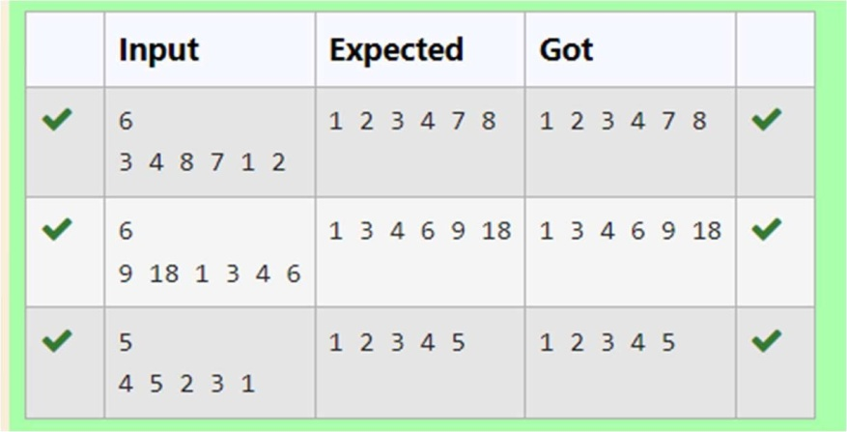

**Ex. No. : 10.2 Date: 01.06.24**

.

**Department of Computer Science and Engineering** | **Rajalakshmi Engineering College**

170



**Register No.: 230701370 Name B.VARSHA**

# Peak Element

Given an list, find peak element in it. A peak element is an element that is greater than its neighbors.

An element a[i] is a peak element if

A[i-1] <= A[i] >=a[i+1] for middle elements. [0<i<n-1] A[i-1] <= A[i] for last element [i=n-1]

A[i]>=A[i+1] for first element [i=0]

**Input Format**

The first line contains a single integer n , the length of A . The second line contains n space-separated integers,A[i].

**Output Format**

**Print** peak numbers separated by space.

**Sample Input**

5

8 9 10 2 6

**Sample Output**

10 6

**For example:**



|  |  |
| --- | --- |
| **Input** | **Result** |
|  | |
| 4  12 3 6 8 | 12 8 |



## Program:

a=int(input())

lst1=[str(x) for x in input().split(" ")] lst2=[]

lst=[] g=0

for i in lst1:

if i.isdigit(): g=int(i) lst.append(g)

for i in range(0,a): if(i==0):

if(lst[i]>=lst[i+1]): lst2.append(lst[i])

elif(i>0 and i<a-2):

if(lst[i]>=lst[i-1] and lst[i]>=lst[i+1]): lst2.append(lst[i])

elif(i==a-1): if(lst[i]>=lst[i-1]):

lst2.append(lst[i]) for i in lst2:

print(i,end=" ")

.

**Department of Computer Science and Engineering** | **Rajalakshmi Engineering College**

171

.

**Department of Computer Science and Engineering** | **Rajalakshmi Engineering College**

172



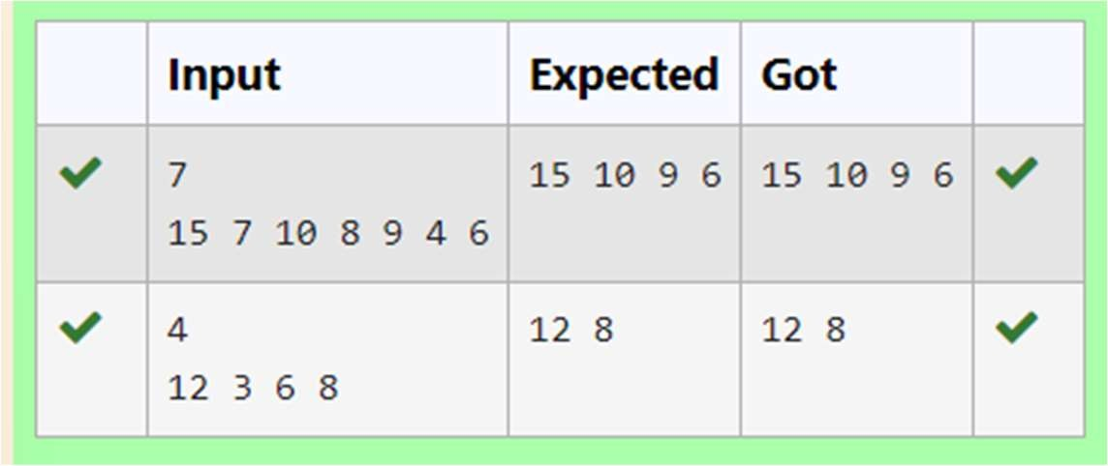

**Ex. No. : 10.3 Date: 01.06.24**



**Register No.: 230701370 Name: B.VARSHA**

# Merge Sort

Write a Python program to sort a list of elements using the merge sort algorithm.

**For example:**



|  |  |
| --- | --- |
| **Input** | **Result** |
|  | |
| 5  6 5 4 3 8 | 3 4 5 6 8 |

## Program:

def merge_sort(arr): if len(arr) > 1:

mid = len(arr) // 2 left_half = arr[:mid] right_half = arr[mid:] merge_sort(left_half) merge_sort(right_half) i = j = k = 0

while i < len(left_half) and j < len(right_half): if left_half[i] < right_half[j]:

arr[k] = left_half[i] i += 1

else:

.

**Department of Computer Science and Engineering** | **Rajalakshmi Engineering College**

173

arr[k] = right_half[j] j += 1

.

**Department of Computer Science and Engineering** | **Rajalakshmi Engineering College**

174



k += 1

while i < len(left_half): arr[k] = left_half[i]

i += 1

k += 1

while j < len(right_half): arr[k] = right_half[j]

j += 1

k += 1

def main():

n = int(input())

arr = list(map(int, input().split())) merge_sort(arr)

for num in arr: print(num, end=" ")

if name == " main ": main()

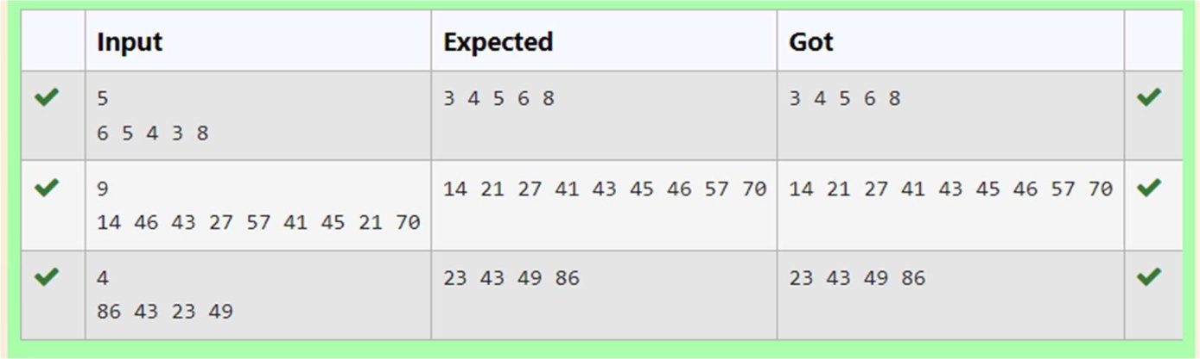

.

**Department of Computer Science and Engineering** | **Rajalakshmi Engineering College**

175



**Ex. No. : 10.4 Date: 01.06.24**

.

**Department of Computer Science and Engineering** | **Rajalakshmi Engineering College**

176



**Register No.: 230701370 Name: B.VARSHA**

**Sum of Two numbers**

An list contains N numbers and you want to determine whether two of the numbers sum to a given number K. For example, if the input is 8, 4, 1, 6 and K is 10, the answer is yes (4 and 6). A number may be used twice.

## Input Format

The first line contains a single integer n , the length of list The second line contains n space-separated integers, list[i]. The third line contains integer k.

**Output Format** Print Yes or No. **Sample Input**

7

0 1 2 4 6 5 3

1

## Sample Output

Yes

## For example:



|  |  |
| --- | --- |
| **Input** | **Result** |
| 5 | Yes |
| 8 9 12 15 3 |  |
| 11 |  |
|  |  |
| 6 | No |
| 2 9 21 32 43 43 1 |  |
| 4 |  |

.

**Department of Computer Science and Engineering** | **Rajalakshmi Engineering College**

177



**Program:**

n=int(input())

a=[int(x) for x in input().split()] k=int(input())

flag=0

if len(a)!=n:

print("No") flag=1

for i in a: for j in a:

if i+j==k and flag==0: flag=1

print("Yes") break

if flag==0: print("No")

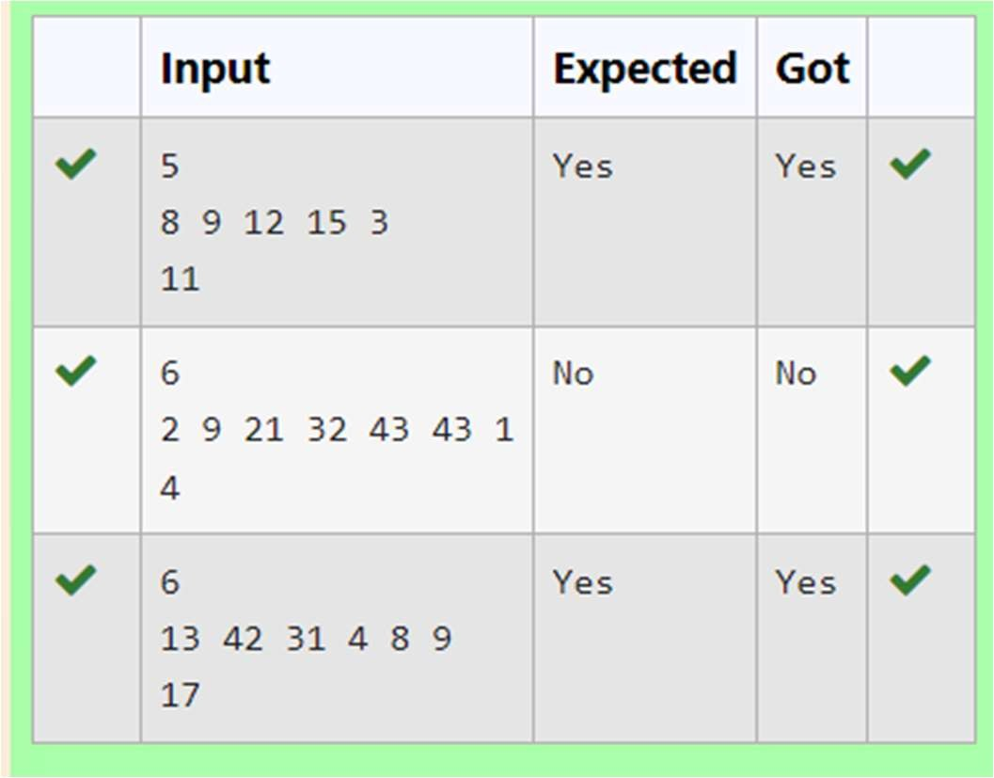



**Ex. No. : 10.5 Date: 01.06.24**

**Register No.: 230701370 Name: B.VARSHA**

# Frequency of Elements

To find the frequency of numbers in a list and display in sorted order.

**Constraints:** 1<=n, arr[i]<=100 **Input:**

1 68 79 4 90 68 1 4 5

**output:**

1 2

4 2

5 1

68 2

79 1

90 1

**For example:**

.

**Department of Computer Science and Engineering** | **Rajalakshmi Engineering College**

178

.

**Department of Computer Science and Engineering** | **Rajalakshmi Engineering College**

179



|  |  |
| --- | --- |
| **Input** | **Result** |
|  | |
| 4 3 5 3 4 5 | 3 2 |
|  | 4 2 |
|  | 5 2 |

## Program:

lst5=[int(x) for x in input().split(" ")] lst=sorted(list(set(lst5)))

c=0

for i in lst: c=0

for j in lst5: if(i==j):

c=c+1

print("%d %d"%(i,c))

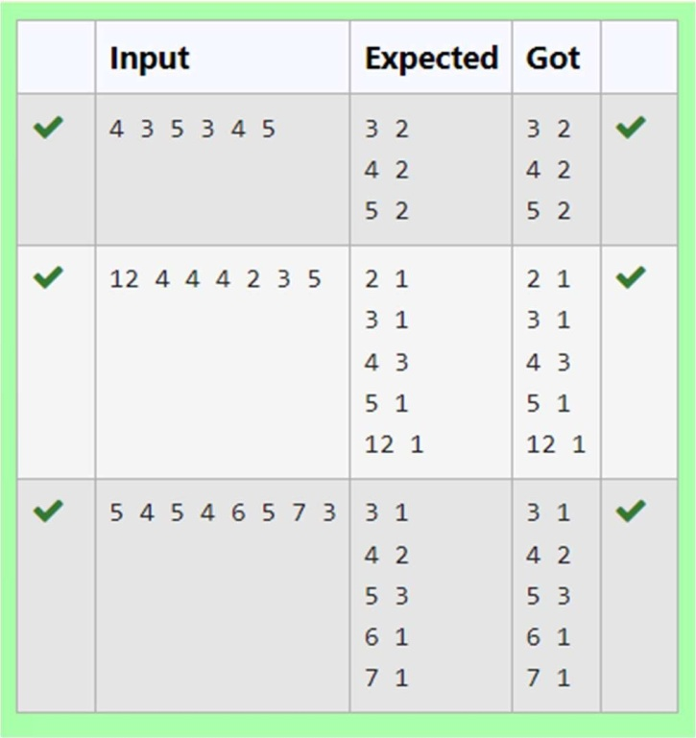

.

**Department of Computer Science and Engineering** | **Rajalakshmi Engineering College**

180

